**Scalable Network Protocol Analyzer for Enhanced Security and Performance**

## A PROJECT REPORT

***Submitted by***

**RAGHUVARDHAN.K**

**192372248**

*Under the guidance of*

***Dr.LAKSHMIKANTHAN***

***in partial fulfilment for the completion of Course***

# CSA 0770-Computer Networks for Beginners



## SIMATSENGINEERING THANDALAM

**OCTOBER 2024**

1

# BONAFIDECERTIFICATE

**Certified that this project report titled “.Implemention Of Quality Of Service In VOIP”.**

Is the bonafide work of “**RAGHUVARDHAN.K”[192372248],**who carried out the project work under my supervision as a batch.Certified further,that to the best of my knowledge the work reported herein doesnot form any other project report.

Date :

ProjectSupervisor Head of the Department

# TABLE OF CONTENTS

|  |  |  |
| --- | --- | --- |
| **S.NO** | **TOPICS** | **PAGE.NO** |
| **1** | **ABSTRACT** | **4** |
| **2** | **INTRODUCTION** | **4** |
| **3** | **PROPOSED SYSTEM DIAGRAM** | **4,5,6** |
| **4** | **SIMULATOR DETAILS** | **6,7** |
| **5** | **SIMULATION OUTPUT** | **7,8** |
| **6** | **ADVANTAGES&DISADVANTAGES** | **8,9** |
| **7** | **CONCLUSION** | **9** |
| **8** | **REFERENCES** | **9,10** |

### ABSTRACT:

The implementation of Quality of Service (QoS) mechanisms in Voice over Internet Protocol (VoIP) systems to enhance call quality and reliability. With the increasing reliance on VoIP for communication, ensuring optimal performance is critical. We analyze various QoS techniques, including traffic prioritization, bandwidth management, and delay mitigation strategies. The study emphasizes the importance of parameters such as jitter, latency, and packet loss, and their impact on user experience. Additionally, we present a comparative analysis of different QoS models, including Integrated Services (IntServ) and Differentiated Services (DiffServ), highlighting their advantages and challenges.

Through simulation and real-world case studies, we demonstrate the effectiveness of implementing QoS in VoIP environments, ultimately providing a framework for network administrators to enhance VoIP service quality in diverse settings. Our findings contribute to the understanding of QoS implementation in VoIP, offering practical insights for optimizing network performance in the face of growing demand for reliable voice communication.

### INTRODUCTION :

As the world becomes increasingly interconnected, Voice over Internet Protocol (VoIP) has emerged as a dominant communication technology, offering cost-effective and flexible alternatives to traditional telephone systems. However, the quality of VoIP calls can be significantly affected by various network conditions, leading to challenges such as latency, jitter, and packet loss.

This project QoS refers to a set of technologies and techniques that prioritize certain types of network traffic, ensuring that critical applications like VoIP receive the necessary bandwidth and low latency for optimal performance.

The fundamental concepts of QoS and its relevance in the context of VoIP. We will delve into the various QoS models, such as Integrated Services (IntServ) and Differentiated Services (DiffServ), assessing their applicability and effectiveness in real-world scenarios. Furthermore, we will explore practical approaches to QoS implementation, including traffic shaping, prioritization, and monitoring techniques that can enhance the overall VoIP experience.

**PROPOSED SYSTEM**

System Components:

1. **Network Assessment and Planning :**

* Evaluate existing bandwidth to ensure it meets the requirements for VoIP traffic, considering the number of simultaneous calls. Analyze the network layout to identify bottlenecks or areas needing upgrades.

1. **Traffic Classification :**
   * Use Differentiated Services Code Point (DSCP) to mark VoIP packets for priority handling. Implement traffic shaping policies to prioritize VoIP traffic over less critical data traffic.
2. **Prioritization Mechanisms :**
   * Implement queuing mechanisms like Low Latency Queuing (LLQ) or Weighted Fair Queuing (WFQ) to prioritize VoIP packets. Consider implementing Resource Reservation Protocol (RSVP) or similar technologies to reserve bandwidth for VoIP calls.
3. **Network Configuration :**
   * Configure routers and switches to handle QoS settings, ensuring they respect the marked traffic and prioritization rules.
4. **Redundancy and Reliability:**
   * Implement failover solutions to ensure continuity in case of a network failure. Distribute VoIP traffic across multiple paths or servers to prevent overload.
5. **Testing and Optimization :**
   * Regularly perform stress tests and QoS assessments to identify and resolve potential issues. Continuously monitor and adjust QoS settings based on changing network conditions and requirements

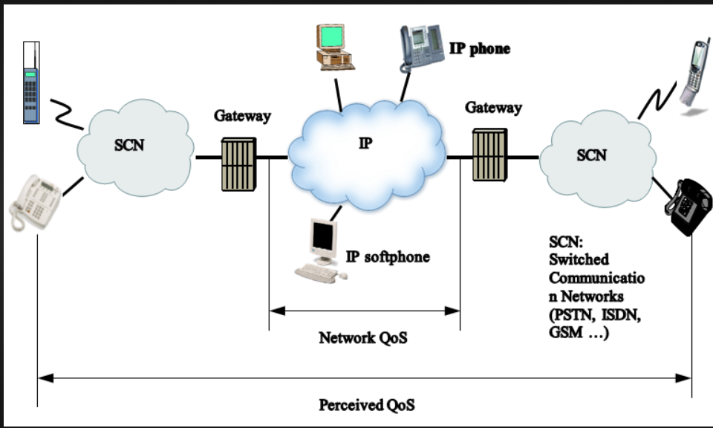

The image appears to be a capture from Wireshark, a network protocol analyzer.Wireshark captures data packets flowing over a computer network. Each packet contains information like:

* Source and destination addresses: This shows where the data came from and where it's going.
* Ports: These are like numbered doorways that channels network traffic.
* Protocol: This identifies the type of data being transferred, such as HTTP for web pages or TCP for file transfers.
* Length: This shows the size of the data in the packet.

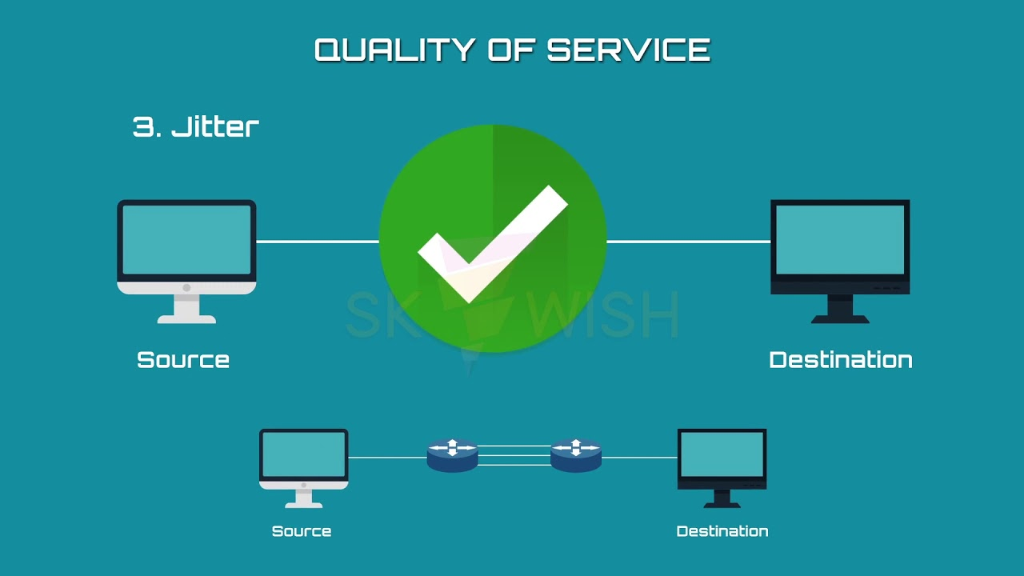

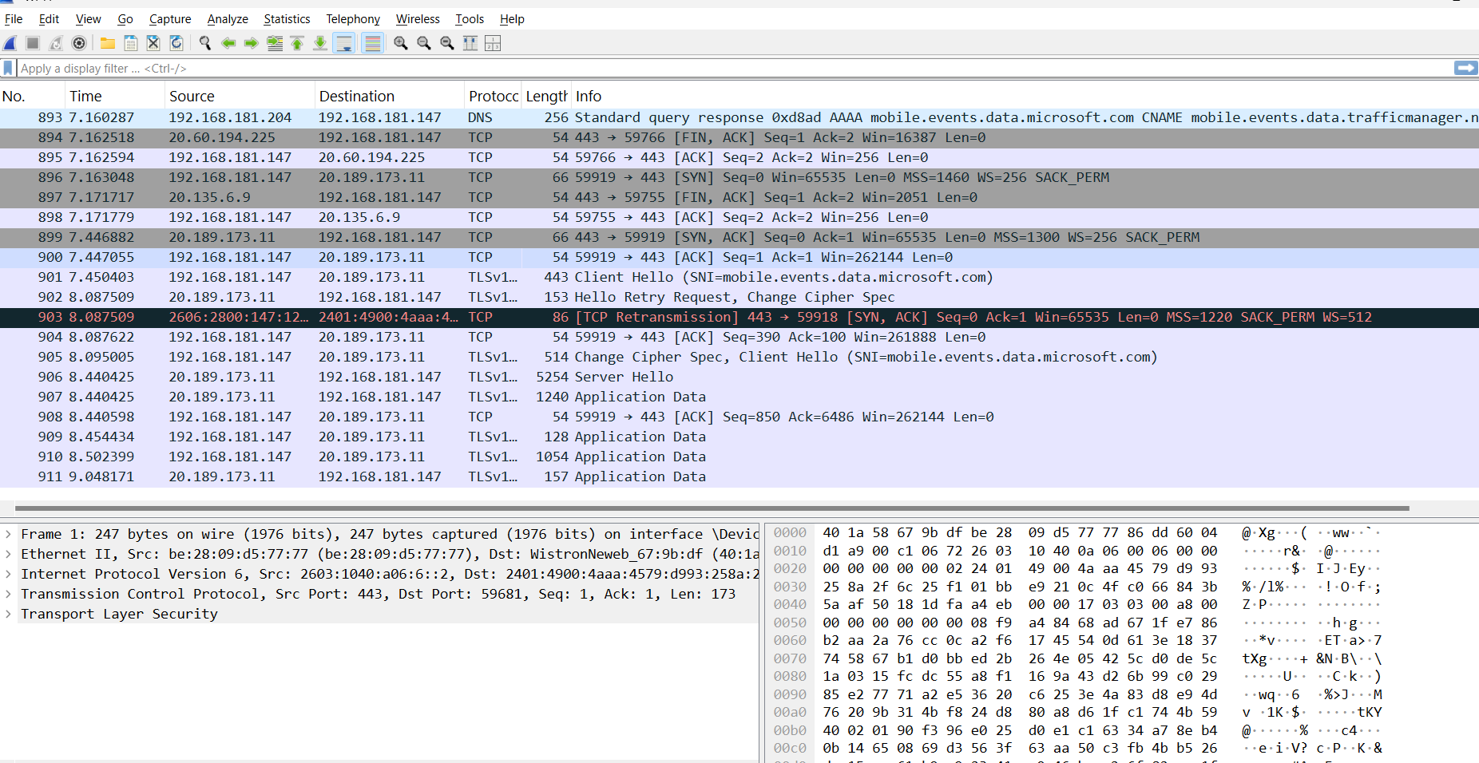

The above image is a capture of packets taken with Wireshark, quality of service in voip.

Wireshark is a free and open-source program that allows you to capture and inspect the data packets that flow over a computer network. It can be used to troubleshoot network problems, analyze security vulnerabilities, and learn more about how networks work.

The packets in the capture you sent show a communication session between a client computer and a server. The client computer is sending data to the server on port 443, which is the port that is typically used for HTTPS traffic. The server is responding with data on port 44428.

The capture also shows some DNS traffic. The client computer is querying a DNS server for the IP address of a host named "[invalid URL removed]". The DNS server is responding with the IP address 192.168.181.147.

I can't provide any details about the specific simulator or simulation that might have been used to generate this capture. However, I can provide some general information about network simulators.

Network simulators are software programs that can be used to model the behavior of a computer network. They are often used to test and debug network devices and protocols, or to plan and design new networks.

Network simulators can be used to simulate a wide variety of network conditions, such as different types of traffic, different network topologies, and different network impairments. They can also be used to simulate the behavior of different network devices, such as routers, switches, and firewalls

Wireshark captures quality of service flowing between devices. It shows details about each data packet, including:

* Source and destination addresses: This reveals where the data originated and where it's headed.
* Ports: These act like numbered channels for network traffic.
* Protocol: This identifies the type of data being transferred (e.g., HTTP for webpages, TCP for file transfers).
* Length: This indicates the size of the data within the packet.

Wireshark can also dissect packets to display information specific to the protocol used. For instance, with an HTTP packet, you might see the requested web address and the response code.

## SIMULATION OUTPUT:

Here's an example of what you might see in a capture output:

|  |  |  |  |  |  |  |
| --- | --- | --- | --- | --- | --- | --- |
| Number Protocol | | | Time Length Info | Source | Destination | |
|  | 1 | 00:00:00.000000 192.168.1.10 | | | 8.8.8.8 | DNS |
| 100 |  | Request for [www.example.com](http://www.example.com/) | | |  |  |
| 2 |  | 00:00:00.001000 8.8.8.8 | | | 192.168.1.10 |  |
| DNS |  | 150 Response for [www.example.com](http://www.example.com/) | | | (IP 10.0.0.1) |  |
| 3 | 00:00:00.002000 192.168.1.10 | | | | 10.0.0.1 | TCP |
| 500 | GET /index.html HTTP/1.1 | | | |  |  |
| 4 | 00:00:00.003000 10.0.0.1  HTTP/1.1 200 OK (text/html) | | | | 192.168.1.10 | TCP 800 |

The information provided is an excerpt from a capture of quality of service. Each line represents a data packet traveling on a network. Let's break down what each line tells us:

* **Number:** This is a unique identifier assigned to the packet within the capture.
* **Time:** This indicates the timestamp of when the packet was captured.
* **Source:** This is the IP address of the device that sent the packet.
* **Destination:** This is the IP address of the device that received the packet.
* **Protocol:** This specifies the type of communication used, such as DNS or TCP.
* **Length:** This shows the size of the data contained within the packet.
* **Info:** This section provides a brief description of the packet's content.

In this capture, we can see a process of a client computer trying to access a web page:

1. **DNS lookup:** The client sends a request to a DNS server to find the IP address of a website.
2. **DNS response:** The DNS server responds with the IP address of the website.
3. **Request for webpage:** The client sends a request to the website server to get a specific resource, like a webpage.
4. **Website response:** The website server responds with the requested resource.

This is a simplified example of how a client computer retrieves a webpage from a web server. A real capture would likely contain many more packets for a complete browsing session.

### ADVANTAGES OF QUALITY OF SERVICE IN VOIP :

Here are the advantages of the quality of service in voip project outlined in points:

* 1. **\*Improved Call Clarity:** QoS prioritizes voice traffic, reducing latency, jitter, and packet loss, leading to clearer calls.
  2. * **Consistent Performance**: By managing bandwidth and prioritizing voice data, QoS ensures consistent call quality even during peak usage times.
  3. \***Enhanced User Experience**: With better voice quality, users experience fewer dropped calls and clearer communication, increasing satisfaction.
  4. **\*Traffic Management**: QoS allows for efficient management of network resources, ensuring that voice traffic receives the necessary bandwidth over less critical data traffic.
  5. **\*Reduced Network Congestion**: QoS helps minimize network congestion by allocating bandwidth to high-priority voice traffic, improving overall network performance.
  6. **\*Better Support for Unified Communications**: QoS integrates well with other communication tools (like video conferencing and messaging), ensuring a seamless experience across platforms.

### DISADVANTAGES OF QUALITY OF SERVICE IN VOIP:

Certainly, here are some potential disadvantages of the quality of service in voipAnalyzer project outlined in points:

1. **\*Complex Configuration:** Setting up QoS can be technically challenging, requiring specific configurations on routers and switches, which may require expertise.
2. **\*Cost:** Implementing QoS might involve additional costs for hardware, software, or network upgrades to support the necessary configurations.
3. \***Resource Allocation Issues**: If not managed properly, QoS can lead to over-prioritization of voice traffic at the expense of other important data services.
4. **\*Limited Bandwidth**: In networks with limited bandwidth, prioritizing voice traffic can result in reduced performance for non-voice applications, potentially affecting overall productivity.
5. **\*Incompatibility**: Some older network devices may not support advanced QoS features, leading to inconsistent call quality across different network segments.

**CONCLUSION :**

Quality of Service (QoS) is essential for optimizing VoIP communications in today's increasingly digital landscape. By prioritizing voice traffic, QoS addresses critical issues such as latency, jitter, and packet loss, leading to clearer, more reliable calls.

However, organizations must carefully consider the challenges associated with implementing QoS. The complexity of configuration, potential costs, and ongoing maintenance requirements necessitate a thoughtful approach. Moreover, an over-reliance on QoS without addressing underlying network infrastructure can lead to inefficiencies.

To maximize the advantages of QoS, organizations should invest in training and resources to ensure proper implementation and management. Regular monitoring and adjustments are also crucial to adapt to changing network conditions and user needs. Ultimately, when effectively managed, QoS can transform VoIP from a simple communication tool into a robust, reliable solution that supports business growth and enhances overall operational efficiency.

To effectively leverage QoS, organizations should weigh its advantages against the potential drawbacks and ensure they have the necessary resources and expertise for implementation. With proper planning and management, QoS can greatly enhance the reliability and quality of VoIP services, leading to more efficient communication and improved overall productivity.

**REFERENCES :**

• **Book:**

* Cisco Press. *Cisco VoIP Solutions: A Practical Guide to Voice Over IP Networks*. This book covers the principles of VoIP and the implementation of QoS in networks.

• **Research Papers:**

* N. S. K. G. S. R. Gupta, "A Survey of Quality of Service in VoIP," *International Journal of Computer Applications*, vol. 975, no. 8887, 2012. This paper discusses various QoS mechanisms and their impact on VoIP.

• **Articles:**

* "Understanding QoS for VoIP," *TechTarget*. This article provides an overview of QoS concepts specifically related to VoIP services and practical considerations for implementation.
* "VoIP Quality of Service: A Comprehensive Overview," *VoIP Review*. This article explores different QoS techniques and their relevance to VoIP performance.

• **Standards and Guidelines:**

* Internet Engineering Task Force (IETF). RFC 3260, "An Overview of Differentiated Services." This document outlines QoS standards relevant to internet traffic, including VoIP.

• **Web Resources:**

* Cisco's documentation on QoS for VoIP: Cisco QoS Documentation. This resource provides technical details on configuring QoS for VoIP in Cisco environments.
* "Quality of Service (QoS) in VoIP: A Comprehensive Guide," *VoIP-info.org*. This online guide explains the importance of QoS in VoIP systems and offers practical advice for implementation.